Pathfinder 5.2

Table of Contents
Pathfinder 5.2 1
Table of Contents 1
Introduction: Pathfinder 5.2 2
Pathfinder Control Center 4
Read Data Files 7
Proximity Data File Format 8
Data Coherence 10
Data Correlations 11
Average Data 11
Derive Pathfinder Networks 12
Compare Networks 13
Network Layout 15
Sample Data Sets 15
Rate Program (to Collect Ratings of Pairs of Terms) 16

Introduction: Pathfinder 5.2
Pathfinder 5.2 is an implementation of Pathfinder software for Microsoft Windows. It follows several versions of a software package PCKnot developed for DOS systems several years ago. Here are some basics about Pathfinder.
A Pathfinder network is derived from proximities for pairs of entities. Proximities can be obtained from similarities, correlations, distances, conditional probabilities, or any other measure of the relationships among entities. The entities are usually concepts of some sort, but they can be anything with a pattern of relationships. In the Pathfinder network, the entities correspond to the nodes of the generated network, and the links in the network are determined by the patterns of proximities. For example, if the proximities are similarities, links will connect nodes of high similarity. The links in the network will be undirected (lines) if the proximities are symmetrical for every pair of entities. Symmetrical proximities mean that the order of the entities is not important, so the proximity of i and j is the same as the proximity of j and i for all pairs of i,j. If the proximities are not symmetrical for every pair, the links will be directed (arrows).
Pathfinder uses two parameters. (1) The q-parameter which constrains the number of indirect proximities examined in generating the network. The q- parameter is an integer value between 2 and n-1, inclusive where n is the number of nodes or items). (2) The r-parameter defines the metric used for computing the distance of paths (cf. the Minkowski r-metric). The r-parameter is a real number between 1 and infinity, inclusive. A network generated with particular values of q and r is called a PFnet(q, r). Both of the parameters have the effect of decreasing the number of links in the network as their values are increased. The network with the minimum number of links is obtained when q = n-1 and r = infinity, i.e., PFnet(n-1,infinity).
With ordinal data, the r-parameter should be infinity (inf). Other values of r require data measured on a ratio scale. This level of measurement is difficult to achieve, so usually r should be set to infinity. The q-parameter can be set to the value that yields the desired number of links in the network. As q decreases, links may be added to the network.
Further information on Pathfinder networks and several examples of the application of PFnets to a variety of problems can be found in:
Pathfinder Associative Networks: Studies in Knowledge Organization Edited by: Roger W. Schvaneveldt Publication Date: 1990 Published by: Ablex Publishing Corp. 355 Chestnut Street Norwood, NJ 07648
The main screen of the Pathfinder graphical user interface is shown on the next page.

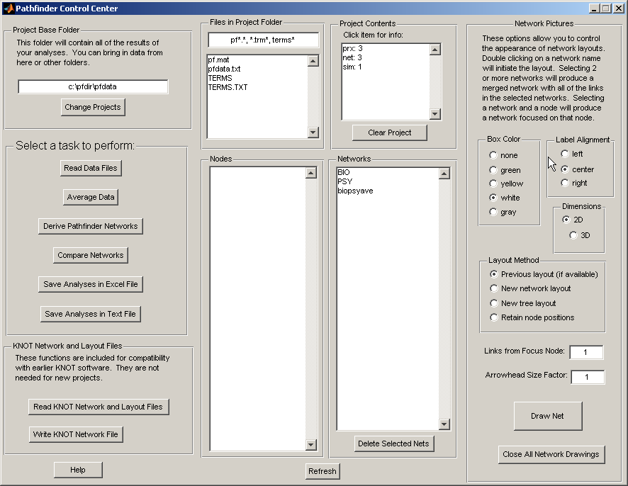

Pathfinder Control Center
The Pathfinder Control Center allows you to initiate the functions accomplished by the software. Let’s review the various controls and options. Each new window launched by the software will be described in detail in subsequent sections. The italics below refer to sections of the interface. The items shown in bold below refer to actions you can take.
Project Base Folder (PBF) is where the data you create are stored. Select this folder as you begin a project. Different projects should be located in different folders. You can keep all of the data files in this same folder, or you can retrieve them from other folders as you work. In any case, the results of your work will be stored in the PBF. The PBF should contain the term.txt file or other term files as discussed below. Change Projects will allow you to select the project folder you wish to work on. The last project you worked on will be where the program starts when you startup again.
Select a task to perform contains buttons that accomplish critical computations. Each button will launch a new window to assist you in the task. More details about each button will be given in later sections on the windows for each button.
- Read Data Files allows you to select data files stored on your disks and bring them into the project.
- Average Data will allow you to select some of the data sets to average, creating new average data sets.
- Derive Pathfinder Networks allows you to select data sets and create networks. You may create more than one network from each data set because you can vary the parameters of the network generation.
- Compare Networks allows you to select sets of networks to compare. Details are provided in a later section.
- Exporting Analyses. There are two methods for exporting data from the Pathfinder application, to an Excel file or to a plain text file. Both methods deliver: (a) summaries of the proximity data read into the project including the coherence of each data set and correlations of the data in all pairs of data files, (b) summaries of the networks produced in the project including the parameters used, number of links produced, types of links, and whether loops are present, and (c) the results of your network comparisons including the number of links networks have in common (com), the number of links in common less the number expected by chance (ccom), the similarity measure (sim), similarity corrected for chance (csim), and the probability of obtaining at least the number of observed common links by chance. See the section Make Statistical Comparisons for details on the data saved.
- Save Analyses in Excel File will store the statistical results of all of your analyses in an excel file “pfdata.xls” in the Project Base Folder
- Save Analyses in Text File will store the statistical results of all of your analyses in a text file “pfdata.txt” in the Project Base Folder.
KNOT Network and Layout Files provides for reading and writing files that are compatible with the earlier versions of the KNOT software for PC’s and Macs. These functions may not be needed for projects conducted solely with the new software. Read KNOT Network and Layout Files will allow you to select layout (.lo) or pfnet (.pf) files created by earlier software and bring them into the project. Write KNOT Network File will create an old format network or layout file from a network currently in the project.
Help opens this document in windows.
Files in Project Folder shows you the files in the PBF. You can limit which files are shown by setting the filter in the panel. Click on a file name to open that file in a windows application.
Nodes is a list of node labels for a selected network. It shows a list of the terms taken from a file, “terms.txt” or “terms,” if it exists in the Project Base Folder. If different data sets have different terms, they should be in files called “<data>.trm” or “<data>.trm.txt” where <data> is the name of the corresponding data file, “<data>.prx” or “<data>.prx.txt”. In this case, a list of these “.trm” files is shown in the terms window. The terms are the node labels for drawings of the networks. It pays to keep the labels short so the networks look reasonable. The terms file must follow a simple format. The label for each node is placed on a separate line in a text file. The first line is the label for the first node and so on. If you are using only one set of labels for one or more networks, use TERMS.txt as the name of the file. If you have different terms for different data sets in a single sub-directory on your disk, use the name prxfile.TRM where prxfile is the name of the proximity data file. For example, if you have proximity data files called FOO1.PRX.TXT and FOO2.PRX.TXT, the corresponding terms files should be named FOO1.TRM.TXT and FOO2.TRM.TXT. These naming conventions are used by the Pathfinder software.
Project Contents shows how many data sets, networks, and similarity comparisons are in the workspace at the moment. In a new project, this will be empty. Click on an item to show a summary of the data in the item. Clear Project will erase all of the information stored as a result of analyzing data for a project, allowing for a fresh start. The data files will still be available. Only the results of using the Pathfinder program will be cleared.
Networks shows a list of networks that have been generated in the project. When a network is selected, the nodes for that network are shown in the Nodes panel. Double clicking on a network will produce a picture of the network. Selecting a network and a node will produce a picture of the part of the network focused on that node. All nodes within the Links from Focus Node number of links will be included in the focus picture. If multiple networks are selected, then Draw Net will produce a network which merges the links from all selected networks. Delete Selected Nets will remove the selected networks from the project. The associated proximity data are not affected.
Refresh updates all of the lists on the screen.
Network pictures contains options to assist you in generating pictures of networks. Select networks in the Networks list window. Selecting one network will result in a picture of that network. Selecting more than one network will result in the creation of a new network which merges the links from all of the selected networks. Obviously networks must be compatible to be merged.
You can select the alignment of the label with respect to the node location, the color of a box, if any, and whether to provide a 2 or 3 dimensional display. Because you can rotate the pictures, 3D can often be useful.
Layout Method provides various options for determining the positions of the nodes in the picture. Select “Previous layout (if available)” if you want to recall the positions from an earlier display of the same network. If the positions are not available, it will compute new ones. Select “New network layout” if you want to discard the old positions and generate new ones in a network format. Select “New tree layout” if you want a tree-style layout. Select “Retain node positions” if you want the nodes to be in the same position as the last displayed picture. This can facilitate comparing different networks by keeping the nodes in the same position. If you first generate a merged network with two network you want to compare, then keep the node positions while selecting each of the two networks in turn. Now you can click alternatively on the toolbar icons of the two nets and see the links change as you switch.
Links from Focus Node specifies which nodes to include in a focus picture on a single node. All nodes within the specified number of links will be included.
Arrowhead Size Factor allows you to control the size of arrowheads in layouts of directed networks – values less than one will decrease the size, values greater than one will increase the size.
Draw Net simply initiates the network drawing. It must be used when more than one network is selected. It may be used with only one network, or a drawing of one network can be initiated by double clicking on the network name.
Click Close All Network Drawings to close all of the picture windows at once. The current node positions will be saved. Click Draw Net to get the picture.
Loops (links from a node to itself ) are shown with a border around the name of the node.

Read Data Files
Here is the window for reading proximity data files:
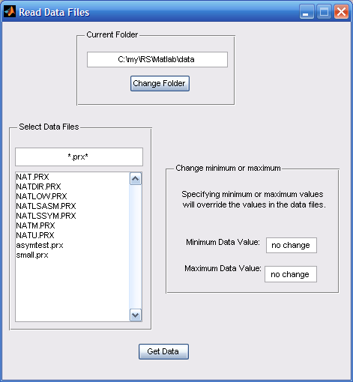
Current Folder shows where we look for the data files. You can Change Folder if the files you want are in another location.
Select Data Files provides a small window you can edit to change the filter for the files you want, “*.prx*” selects all the files with “.prx” somewhere in their name. In the file list below, you can select one or more files with data you want to bring into the project. If you wish, you can edit the minimum and/or maximum data values allowed. This will override the values in the data files (see below). These should usually be left with no change here because you can change them later.
Get Data must be clicked to initiate the reading. The data must follow one of formats described in the next section.

Proximity Data File Format
The data may be in the form of similarities, dissimilarities, probabilities, or distances. With dissimilarities or distances, smaller numbers represent pairs of entities that are close or similar or related and larger numbers represent pairs of entities that are distant or dissimilar or unrelated. The opposite is true of similarities or probabilities, i.e., smaller numbers represent entities that are distant or dissimilar or unrelated and larger numbers represent pairs of entities that are close or similar or related.
The computations actually use distance measures so similarities or probabilities are inverted as they are read in. With distance measures, the distance between an entity and itself (the major diagonal entries in a data matrix) is usually 0 (zero). Pathfinder will handle non-zero entries on the diagonal, however. Such values will lead to "loops" (links from a node to itself) in the network, although they will not be displayed. Data derived from transition probabilities may lead to such non-zero entries for the diagonal. You must be certain that the diagonal in a matrix contains meaningful values. If all diagonal values are equal, they are taken to have 0 distance (or maximum similarity).
All entries in the data must be positive or zero. Negative numbers are not allowed.
A strictly formatted file is required for proximity data. The format of this file is described below.
Data file format. / indicates alternatives:
----------------------------------------------------------------
Line 1: Identification as data file = Data/DATA/data
Line 2: Type of data = similarity/dissimilarity/probability/distance/sim/diss/dist/prob
Line 3: Number of nodes = integer
Line 4: Number of decimal places = integer
Line 5: Minimum data value = real number
Line 6: Maximum data value = real number
Line 7: Order of data values = matrix/upper/lower/list
Line 8: Data
Line 9: Data ...
Line ?: Data
-----------------------------------------------------------------------
The lines in the file must be organized as shown above. For the first six lines, the program reads only the first entry on the line and then goes to the next line. Anything can follow the first entry on the line; the program doesn't use it. Some descriptive information on the line can help to keep things straight, especially after some time has elapsed. Details on the required input are as follows:
Line 1. "Data," "DATA," or "data" is used to identify the file type
Line 2. "similarity," "dissimilarity," "probability," or "distance" (or "sim," "diss," "prob," or "dist") are used to indicate the type of data. With similarities or probabilities, the values are converted to distances using X' = min + max - X. Where min and max are the values on lines 5 and 6 (see below).
Line 3. the number of nodes (or entities) to be analyzed.
Line 4. the number of decimal places in the data values. This is the number of places to the right of the decimal. This value is used for output formatting. This value should reflect the numbers input as data
Line 5. the minimum value in the data set.
Line 6. the maximum data value.
The minimum and maximum values are used as cutoffs in handling the data. Any number in the data outside the minimum - maximum range is treated as infinite distances. Two nodes with infinite distance can never be linked in any network generated by the program. Missing data can be handled by treating them as infinite.
Line 7. "matrix" or "upper" or "lower" or "list." This line specifies the order of the data following this line. Various orders are possible based on a full matrix, an upper triangle, a lower triangle or a list. The lines of data in the file do not have to have these shapes, but the data must be in the same order as they would if the lines did have those shapes.
The following examples may be of help.
matrix:
0 1 3 2 3
1 0 1 4 6
3 1 0 5 5
2 4 5 0 4
3 6 5 4 0
lower:
1
3 1
2 4 5
3 6 5 4
upper:
1 3 2 3
1 4 6
5 5
4
list:
10 pairs
symmetric
2 1 1
3 1 3
3 2 1
4 1 2
4 2 4
4 3 5
5 1 3
5 2 6
5 3 5
5 4 4
These four sets of data would all have the same effect. Of course, if your data are asymmetric, they must be input as a matrix or a list with "nonsymmetric" or “asymmetric” specified. If the data are symmetric, any of the four shapes is acceptable. With the list format, the number of pairs in the list must be specified on the line following "list." The next line specifies whether the pairs define symmetric or nonsymmetric data. With the list format, missing pairs are given infinite distances.
Following the header lines, the data must occur as discussed above. With n nodes (or entities), a matrix representation must contain n² data elements, and upper or lower matrix representation must contain n(n-1)/2 data elements. The list representation must contain 3 numbers for each pair listed, the source entity, the destination entity, and the proximity. The data elements must be separated by one or more spaces and/or line breaks.
The following sample data file is set off by dashed lines.
------------------------------------------------------------------
data
dissimilarities
5 nodes
0 decimal places
0 minimum data value
5 maximum data value
matrix:
0 1 3 2 3
1 0 1 4 6
3 1 0 5 5
2 4 5 0 4
3 6 5 4 0
------------------------------------------------------------------
Notice that both of the data elements with the values of 6 (the first at (2,5), the second at (5,2)) would be treated as infinite distances by the program. This is due to the information on line 6 of the sample data file, namely that the maximum value of the data is 5. These minimum and maximum values can be overridden by the software reading and processing the data.

Data Coherence
When data are read into the project, a measure of coherence is computed for the data set. The coherence measure reflects the consistency of the data. The coherence of a set of proximity data is based on the assumption that relatedness between a pair of items can be predicted by the relations of the items to other items in the set. First, for each pair of items, a measure of relatedness (the indirect measure) is determined by correlating the proximities between the items and all other items. Then, coherence is computed by correlating the original proximity data with the indirect measures. The higher this correlation, the more consistent are the original proximities with the relatedness inferred from the indirect relationships of the items. We have found that the coherence measure often correlates with expertise (or degree of learning). Very low coherence values (less than 0.20 or so) may indicate that raters did not (or could not) take the rating task seriously. We have also found that very low coherence may indicate an error in entering the proximity data so that it is scrambled in some way. For example the proximities may be in the wrong order, one may be missing, or an extraneous one included. All of these errors lead to the incorrect proximities being associated with the pairs of items, so low coherence is likely to result.

Data Correlations
The data correlations are simply the Pearson product-moment correlations of the data sets. These correlations provide a measure of the similarity of data sets.

Average Data
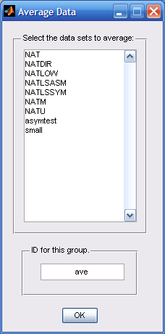
Select the data sets to average allows you to select data sets to average into a new data set.
You should edit the ID for this group to give the average a meaningful name for use in subsequent operations.
You must click OK to initiate the operation.

Derive Pathfinder Networks
Allows you to select data sets to analyze and you can edit the values of the q parameter, the r parameter, the Minimum data value, or the Maximum data value. The default values for the parameters are shown in the figure. Networks created with these parameters will have the same names as the data sets they are derived from. Any change in the parameters will lead to the creation of a new network, and the name will include the values of the changed parameters. For example if we analyzed the data, BIO, with q set to 2, the name of the network would be BIO_q2. If we used the default values, the network name would be the same as the data set, BIO. If you decide to eliminate some data values from consideration, you can use the Minimum and Maximum data values to do so. For example, suppose your data come from a rating scale from 1 to 9 where 9 is highly related. If you decide to exclude any links from ratings less than 3, just set the minimum data value to 3. The network name will reflect this change.
You must click OK to initiate the operation.
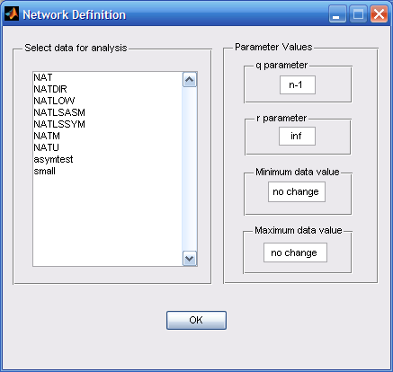

Compare Networks
Here is the window for setting up comparisons. Select networks in the top window and click Define Set 1 or click Define Set 2 to place the selected networks into the appropriate comparison set. Then click OK to initiate the comparisons. You can compare networks in any combination you choose. You can compare all of the networks to all of the networks. You can compare all of the networks to one network. Make the selection so it is meaningful to you. You can later define another set of comparisons if two such sets of comparisons is what you want. If the two sets have different numbers of networks, use Set 1 for the larger set so the output data format will be easier to work with.
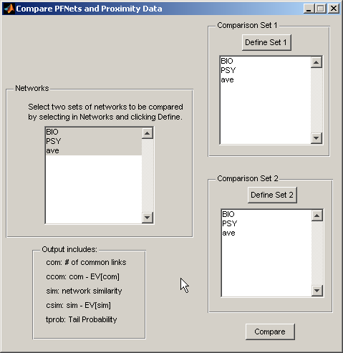
The similarity between two networks is determined by the correspondence of links in the two networks. The similarity is the number of links in common divided by the number of links that are in either network. Two identical networks will yield a similarity of 1 and two networks that share no links will yield similarity of 0. The measure is the proportion of all the links in either network that are in both networks. Also some statistical information is provided about the similarity. The tprob is the probability that the two networks would share the given number of links or more by chance. It can be used as a statistical test of the similarity of two networks. Values corrected for chance are also given for both the number of common links and for similarity. These values reflect how much more (or less) similar two networks are than would be expected by chance.
Similarity measures and their applications are discussed in:
Goldsmith & Davenport (1990), "Assessing structural similarity of graphs," and Goldsmith & Johnson (1990), "A structural assessment of classroom learning." Both in R. Schvaneveldt (Ed.), Pathfinder Associative Networks: Studies in Knowledge Organization. Norwood, NJ: Ablex.
Here is the information provided by the comparison by way of an example:
14 = links in common (com)
11.83 = links in common corrected for chance (ccom)
0.378 = similarity (sim)
0.333 = similarity corrected for chance (csim)
0.000 = probability of com or more links in common by chance (tprob)
In this example, similarity was calculated for the PFnets: PSY and BIO. The output shows the number of links in each network. The number of links common to both networks (com), the difference between the observed and expected number of links in common (ccom), the similarity (sim) [similarity = com / (total links - com) = 14/(25+26-14) = 0.378], the difference between the observed and expected similarity (csim), and the probability of this many or more common links by chance (tprob). You can see in this example that the probability of obtaining this many or more links in common is extremely small (less than .001).
When network similarity is computed for two sets of networks, the above information is provided for every possible pair of networks taking one from each set.

Network Layout
Here is a picture of a displayed network. The title shows the name of the networks and the q and r parameters used to generate it. In this case the network is displayed with no box around the label and the labels are positions to the right of the node position. The tools allow you to move it, resize it, and rotate it. The changes you make to its appearance are saved so when you view it again with “Previous layout (if available),” it will show up just as you left it. Rotations with 3-D layouts are especially impressive. The File menu has the usual options for printing and saving. You can save the figure using various formats to enable you to get the image into other applications. It is also helpful to use screen capture software (e.g., SnagIt) to grab and manipulate the image.
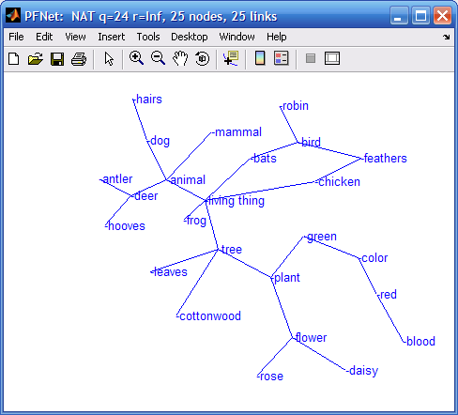
You can click on a node and drag it to move it to a new position (links follow). Moving nodes in a 3D display is not advisable because the positions will change to unexpected locations because you are only viewing a plane section of the 3D layout. When you do move the nodes to new positions, the new node positions are saved so future layouts of the same network will appear as you left it provided you select Previous layout (if available) in the Layout Method options. If you double click on a node, a network focused on the clicked node will appear.

Sample Data Sets
To get the feel of using the software, try running an analysis of the sample data files, PSY.PRX and BIO.PRX. These are averages of ratings obtained from introductory psychology students and from biology graduate students on a collection of living things and some of their properties. Notice the differences in the networks obtained.

Rate Program (to Collect Ratings of Pairs of Terms)
RATE.exe is a basic program for creating proximity data files (files containing raw "nearness" data). It does this by accessing a stored file of terms, pairing them one at a time, and asking the user to rate the relatedness of the pair. The data created by this process is formed into a matrix and saved as a proximity data file. These files are then used by other commands to create PFnets and PFnet layout files. As the sample TERMS and INSTRUCT files will show, RATE is intended to be used as an experimental tool, and will index (in sequential order) the proximity data files it creates. The files are found in the directory, c:\pfdir\pfdata on your disk after Pathfinder is installed.
The RATE program allows you to obtain pairwise ratings of a number of terms using a 9-point rating scale. Unlike other programs, the RATE program uses no command line parameters, but files with particular names are used by the program. Some of these files are required and others are optional. These files must be in the current directory of the currently selected drive. The sample files included show the required formats.
Required Files: TERMS - The file named TERMS must be in the current directory. This file should contain the terms to be rated, one term to a line. The RATE program will present all pairs of these terms in a random order and require a rating for each of the pairs.
INSTRUCT - A file named INSTRUCT must be in the current directory. This file contains instructions to the rater which are simply presented as is on the screen at the beginning of the session. Multiple screens of instructions can be managed by separating the screens with a line containing only the character, ^, in the first position on the line. The program will pause when this line is encountered with the message, "Press the SPACE BAR to continue."
Optional Files: SCALE - If a file named SCALE exists in the current directory, it will be used to determine (1) the type of data being collected, and (2) the labels to be used below the scale presented for the rating. Only two lines are used from this file. The first line must contain either "similarities" or "dissimilarities." Similarities means that the data should be interpreted such that the larger numbers on the scale mean greater similarity. Dissimilarities mean that the larger numbers on the scale mean greater dissimilarity (or greater distance). The second line in the SCALE file must contain the labels that will be displayed with the rating scale. This line is simply written below the scale to give some reference points for the ratings. If there is no SCALE file, the data are considered to be similarities and the scale is labeled UNRELATED on the left-hand side and RELATED on the right- hand side.
DEBRIEF - If a file named DEBRIEF exists in the current directory, it will be transferred to the screen at the completion of the ratings. It must be short enough to fit on one screen. Multiple screens are not accommodated for the DEBRIEF file.
The results of the ratings are stored in the current directory in sequentially numbered files named RATE001.PRX, RATE002.PRX, etc. Each time the program is run, it automatically detects which number to use next by scanning up through the consecutive numbers. If you delete one of the data files, it will be replaced by another file with the same number when the RATE program is run next.

